DL Lab 04 – Answers

**Q7)** 1783 boxes had resulted by the filtering process based on the confident score and class probability. Original box count supposed to be 1805 (19 * 19 * 5, gird size of 19 * 19, and 5 anchor boxes). But after the filtering process, low confidence boxes were filtered out and only 1783 boxes were passed.

The minimum number is 0 if none of the boxes met the passing criteria.

The maximum number is 1805 if all the boxes meet the passing criteria.

**Q8)** Advantage of using anchor boxes includes efficient object detection, improved handling of different object aspects ratios, and scales, Reduction of computational complexity.

The method – Anchor boxes sizes were defined by only using width and height.

**Q 10) Image set 1**

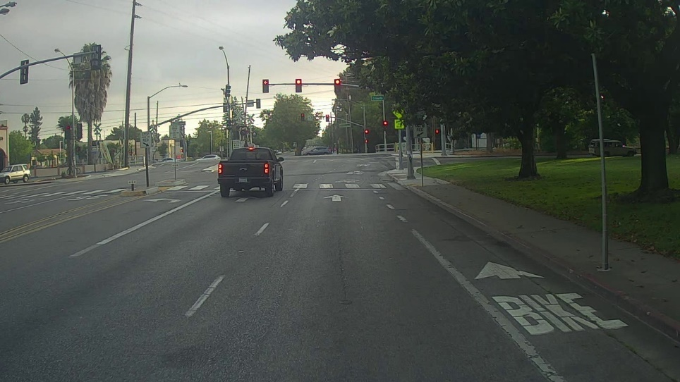

Figure 1.1 Original Image

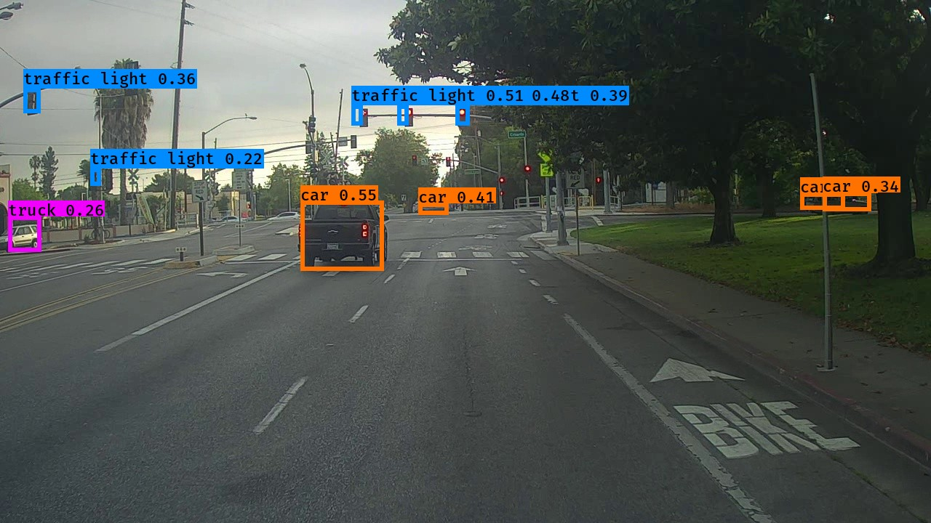

Figure 1.2 Detected Image

Observations –

* Two cars were detected correctly
* 5 traffic lights were detected correctly.
* A car has been detected as a truck.
* A single car has been detected twice (by two boxes)
* Two cars were undetected.
* Three traffic light bounding boxes were slightly off the objects.

**Image set 2**

Figure 1.3 Original Image

Figure 1.4 Detected Image

Observations –

* Two cars were detected correctly.
* Three cars were not detected.
* A car has been detected as a truck.
* Only three signal lights were detected.